

29.2

By Adam Chu



# Plan

|  |  |  |  |  |
| --- | --- | --- | --- | --- |
| Software | Sequence Of Activities | Materials to be used | Time Required  Dates of Install Period | Communications (Manufacturers) |
| Win7 to Win10 | 1. Create Backup of all items on the Server. Files, Programs, User Directories and Logins 2. Select Machines for Conversion 3. Create New Space on NAS in-case of incompatibility or Viral Infection (Allows the Admins to quarantine just the new files) 4. Create Installation Media (Bootable USB or DVD) 5. Create Restore Point so if an update fails midway it does not affect the company significantly | * Installation Media (USB/DVD) * Test PCs * Licence Keys for the Computers or Organisation * User Installation Guide * Access to NAS/Server with admin account & PC & Software | For a full conversion from Win7 - Win10 you would need about 30-60 mins for the installation.  For the date the best time would be on some weekend or after hours when only the technicians will be at site. Or you could assign the upgrade inside a staff holiday | We should tell the employees how long that their workflow will be disrupted and what features are going offline. We should also tell them if they require any other training to use the systems  We should ask management for help planning who and when the update or installed software is going to be deployed to which employees  And we should have access to tech-support from the program manufacturer in case of an accident mid update.  Using Emails or a custom written VOIP / IM application is useful as all communications will have a transcript for a record of information. |
| To update to Win10 you will need:  1 GHz or faster CPU  2GB of RAM for 64-Bit Windows  20GB of HDD space  DX9 or later on the GPU (Or Use Intel Integrated GPU)  Minimum display size 800px*600px  But if you want a good user experience you should have better specifications than this, this is mainly because Windows 7 is slowly losing support. This is affecting the employees as they want to use a more up-to date and rounded software.  Win10 added a better command prompt, and a tiled start menu as well as Virtual Desktops which allow the user to have Chrome and research tabs inside one desktop and have the word and excel applications in another desktop. | | | | |
| Google Chrome | 1. Create a System back-up 2. Select Machines For Installation and Uninstallation of older Browser to keep the server less full up. 3. Create Restore Point 4. Start Download from the Internet as this is NOT a fresh install where there isn’t an OS 5. Run Installation Wizard | * Admin: Account and PC * Stable Internet Connection * Space on NAS and Test PCs’ | The time to completely and format Google Chrome should be around 15-20 Mins.  This should be done after hours or On a staff holiday because the Businesses system could be affected when the installation occurs | The Manufacturer Google having a good access to TS which is documented for cross referencing  You will need to inform management so that they can send out update messages to the potential End Users who have to use Google Chrome  You might need to give potential end users training like using Google Chrome Extensions |
| * Windows 7+ * Intel Pentium 4 or Better * 128MB RAM   This should be better than this if you are doing programming for web, one of the good things about google chrome is the V8 system which allows for JS to be JIT compiled. Also the Mobile Viewer inside of Chrome allows the developer to test an application for mobile. | | | | |
| Adobe Premiere CC | 1. Back Up server and collate all relevant files like .Raw & edited files with the old video editing software in a universal format 2. Check that the Chosen Machines have the Hardware required to edit the footage at the right resolution. 3. Buy Licence Keys and create Installation media Due to the file size it might be better to download it to a portable SSD (Installation Wizard) and then upload it to the server and VMs’ 4. Run Installation media and then run tests for speed and functions. | Space on Server for the installed files and accessories (Program as well as space on the server for edited files)  Internet Connection for the Installation of Programs and creation of the Installation Media  Access to the Server with R&W access this is required to install any program    Having a installation guide can be helpful when doing a mass update of software. | For This installation it should take between 25-40 Mins based on the internet speed  But this is a large file which could slow down the server so having the installation date not on a day where the affected staff will be on site is best. | We will need to have email connections with the:   * The new users for this software as this might be different to the previous video editing software. * Also the new users for this software may require additional hardware and due to latency when editing or viewing videos. * You will need to talk to the managers on how long the update will take and how much it will cost, this is also is useful if there are any delays or problems during an update * You also need to have access to TS from the software manufacturer in-case of lost data or a corrupt files during update and installation |
| Adobe Premiere Minimum Specifications  GPU Nvidia GTX 970: 4GB GDDR5  CPU i5-4590 (Quad Core CPU) HDD 4 GB Free Space (Without files to edit)  8GB of RAM for less than HD 60Hz video  32GB for 4K 60Hz  This application is useful as it allows the user to freely edit and alter recorded video files on the network as well as being industry leading software, the only issue with this program is the high minimum specifications for Premiere. | | | | |

# M2 - Plan for installing and upgrading a piece of software

When preparing for a software installation &/or update the first thing you want to prepare is a list of potential consumers (employees) and a list of compatible computers (Higher Spec like 32GB of RAM and GPU) that will benefit most from an installation. For example (Adobe Premiere CC) will have the most noticeable benefits when installed to the best workstations inside the workplace and only the employees that need it should get the software.

Then you should plan a date for the update which would not be when other employees are not working so that if there is a complication: i.e. Corrupted Installation Files, Wrong Version Installed or due to server issues that its possible to revert to a restore point and restart the installation/upgrade.

Then you should test the program and remove any programs that it would replace i.e. Replacing Internet Explorer with Chrome to save space on the Server and Local Machines. If it’s a program which would require external training and new employees to get the maximum use of software then you need to book and set-up training sessions.

The first item to be installed is the OS (Windows 10) as it is required for the system to allow for .exe files to run and has the generic GUI that all programs installed later will require, this will take about 20 mins, and then will require a bootable storage device to pre-load the OS from when the UEFI BIOS is launched.

This would then be set up with a custom background and then certain applications will be restricted using active directory, for example you want to limit the use of Command Prompt or windows PowerShell as people with access to these sub-programs inside of Win10 could change and access settings and create and run .exe files.

Also after the install of new programs like Premiere Pro which is paid for you want to restrict user input this would allow he business to save money on subscription services and licences.

# How to set up restore points

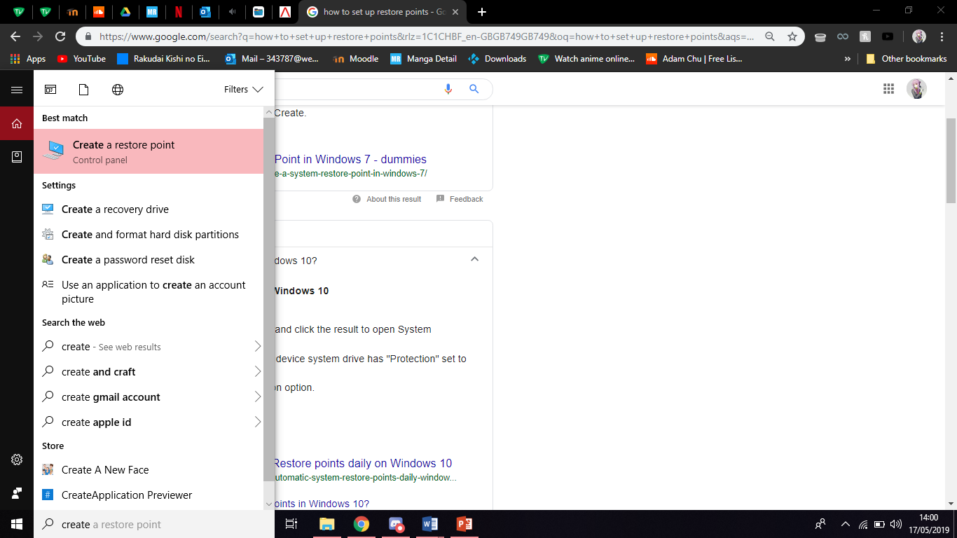

Search for Create a Restore Point

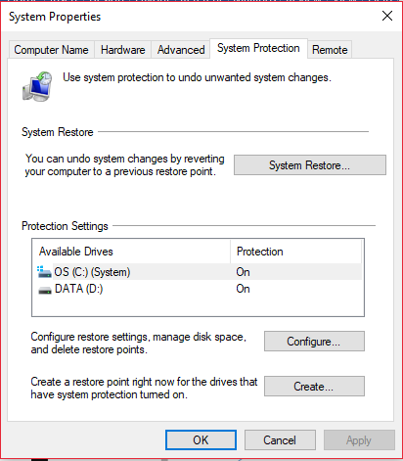

what size of file are allocated to each restore point

Select Which storage location that the restore point this saved to.

Select Previous Restore Point for the system to restore to

Create Restore Point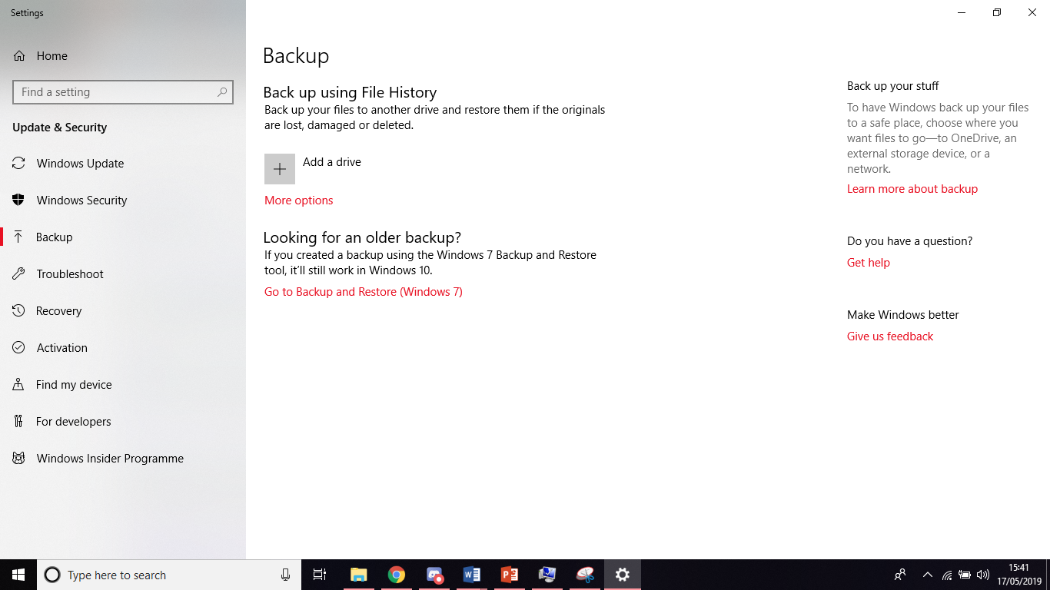



This allows the user to format any Win7 Backups to a Win10 system.

This is where you would have an external drive or NAS show up as a drive which a back-up being created.

The main way to back-out of an update procedure is to have a back-up or restore point pre-installation, this would be saved on the local server. Then you would use the Uninstallation Wizard Included with Windows to force the item to be removed from the network. Then you would load the restore point from before the item was installed originally to remove any incompatible or left over files.

When installing a non-OS application there is the option to cancel an installation or upgrade because this will not affect the computer in a negative way. It should not in theory as the computer is installing a program which only interacts with the OS and RAM and re-writable storage for example when installing Mozilla Firefox (a browser), if you click on the Red X at the top right of the installation wizard it will cancel the installation and remove any related files from the computer.

It is recommended when dealing with larger installations of files like ‘games’, film, 3D and 2D graphics that the user has a back-up or a restore point so that if any files are corrupted or contain viruses (downloading it not from the original source -- Legacy software is a common cause for this) that the can be contained and reset before the installation.

Activating the .exe for the installation wizard

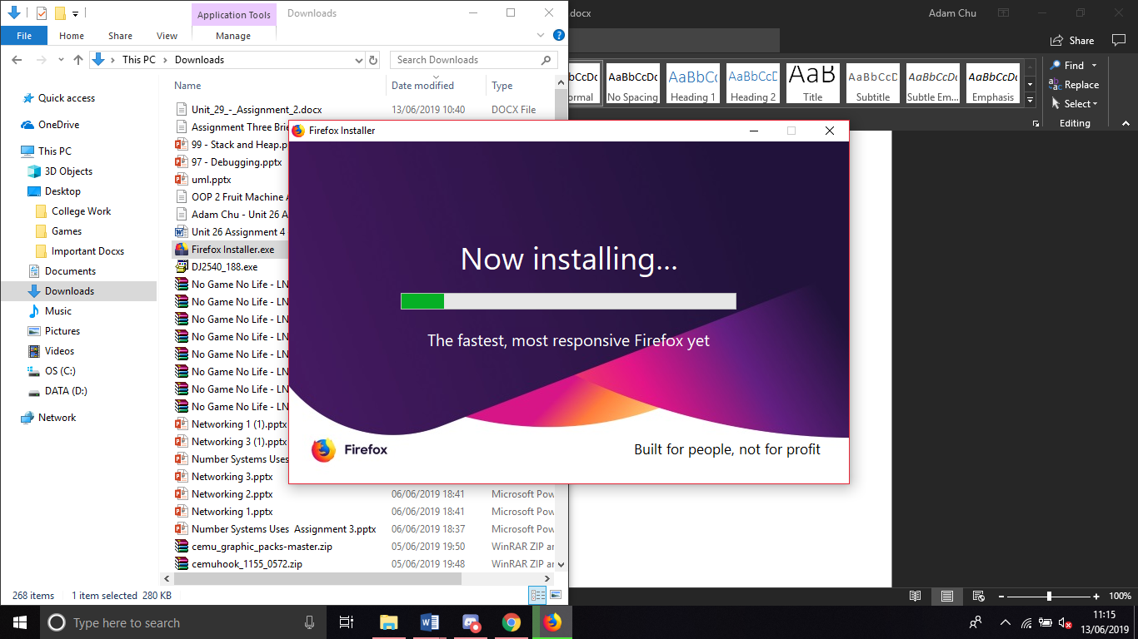

Cancelling the installation using the wizards stop function

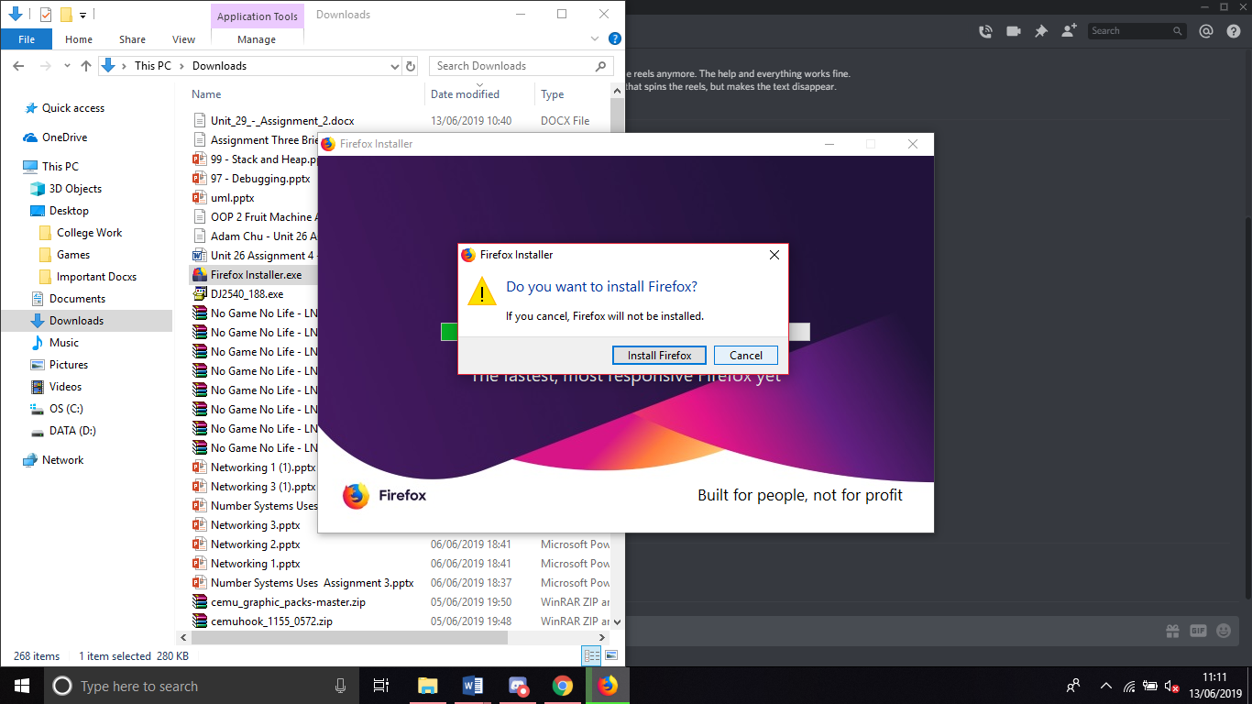

Mozilla Firefox has been uninstalled from this machine